Year 3 Spellings Summer 2 : Week 4 28.06.24
‘sion’ words
1 | vision | Handwriting guide  Use syllables and the sound buttons to help you.  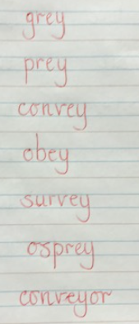
2 | fusion
3 | division
4 | erosion
5 | confusion
6 | revision
7 | decision
8 | invasion
Statutory words!
1 | favourite
2 | February
3 | forward
4 | fruit
5 | grammar
Green: Just learn the green words and statutory words write them into 5 sentences.
Blue: Learn all the words and write them into 6 sentences.
This week children will be tested on either:-
Green: Tested on 12 words in total.
Blue: Tested on 15 words in total.
AND two unlisted words based on the rule.
Spellings: Write each of your words 3 times in your homework book to help you remember how to spell them. Use the handwriting paper and make sure you follow the handwriting guide this week especially as we have started the new handwriting scheme.

Word focus: This week, write a silly/nonsense rhyming poem using your spelling words. Challenge yourself by including the statutory words.

Remember to make sure you are writing neatly and using all appropriate punctuation.
Arithmetic
- Log in to Mathletics.com (direct link: https://community.mathletics.com/signin/#/student) and complete the assigned activities which we have set for you.  - Another chance to practice your 9s. Think about how your 3 times tables will help. Too easy?  Practise linked number facts:  4 x 9 = 36  36 ÷ 9 = 4 |  |  | 9 Times Table  1 x 9 = 9  2 x 9 = 18  3 x 9 = 27  4 x 9 = 36  5 x 9 = 45  6 x 9 = 54  7 x 9 = 63  8 x 9 = 72  9 x 9 = 81  10 x 9 = 90  11 x 9 = 99  12 x 9 = 108

