Year 3 Spellings Autumn 1: Week 2 19/9/24
Rule: ou makes an /u/ sound
1 | touch | Handwriting Practice  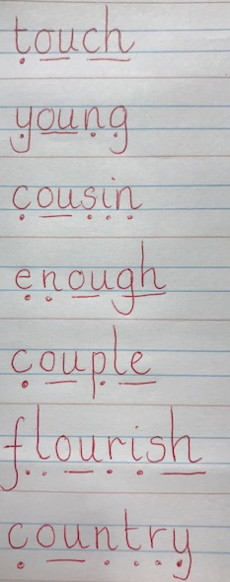  Some children find the sound buttons useful to help them learn the words – use them if you find them useful!
2 | young
3 | cousin
4 | enough
5 | couple
6 | flourish
7 | country
8 | encourage  Statutory:  strange  strength  surprise  thought  through
Green: Just learn the green words and write them into 5 sentences.  Blue: Learn the green and blue words and write them into 5 sentences. |  | Both Green and Blue are to learn the 5 statutory words.
Children will also be given two ‘unseen words’ during the test to assess their understanding of the week’s spelling rule.
Green: Tested on 12 words in total.
Blue: Tested on 15 words in total.
Spellings: Write each of your words 3 times in your homework book to help you remember how to spell them.

Sentence grammar focus: For five chosen rule words (not statutory), write five sentences that include an adverb.

e.g The young cousin encouraged his sister to play quietly.

Remember to make sure you are writing neatly and using all appropriate punctuation.
Arithmetic
- Log in to Mathletics.com (direct link: https://community.mathletics.com/signin/#/student) and complete the assigned activities which we have set for you.  - Learn the 5 times tables – please record in the front of the homework book after the spellings and comprehension. |  |  | 5 times tables  1 x 5 = 5  2 x 5 = 10  3 x 5 = 15  4 x 5 = 20  5 x 5 = 25  6 x 5 = 30  7 x 5 = 35  8 x 5 = 40  9 x 5 = 45  10 x 5 = 50  11 x 5 = 55  12 x 5 = 60

