Year 3 Spellings Autumn 1: Week 3 26/9/24
Rule: ‘i’ sound spelt with a ‘y’ |  | Handwriting Guide:
1 | gym | 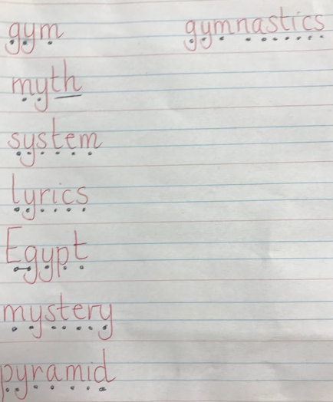
2 | myth
3 | system
4 | lyrics
5 | Egypt
6 | mystery
7 | pyramid
8 | gymnastics
 | Statutory Words
 | enough
 | guide
 | promise
 | woman
 | women
Green: Just learn the green words and write them into 5 sentences.  Blue: Learn the green and blue words and write them into 5 sentences. |  | Both Green and Blue are to learn the 5 statutory words.  Use the sound buttons to help you.
Children will also be given two ‘unseen words’ during the week assess their understanding of the week’s spelling rule.
Green: Tested on 12 words in total.
Blue: Tested on 15 words in total.
Spellings: Write each of your words 3 times in your homework book to help you remember how to spell them.
Sentence grammar focus: For five chosen rule words (not statutory), write five sentences that include an imperative verb e.g. Complete a circuit at the gym.

Remember to make sure you are writing neatly and using all appropriate punctuation.

Arithmetic
- Log in to Mathletics.com (direct link: https://community.mathletics.com/signin/#/student) and complete the assigned activities which we have set for you.  Learn your 10 times tables. |  |  | 10 times tables  1 x 10 = 10  2 x 10 = 20  3 x 10 = 30  4 x 10 = 40  5 x 10 = 50  6 x 10 = 60  7 x 10 = 70  8 x 10 = 80  9 x 10 = 90  10 x 10 = 100  11 x 10 = 110  12 x 10= 120

