Year 3 Spellings Autumn 1: Week 4 3/10/24
Words ending with sure –  Rule: sure it’s pure |  | Handwriting Guide:
1 | measure | 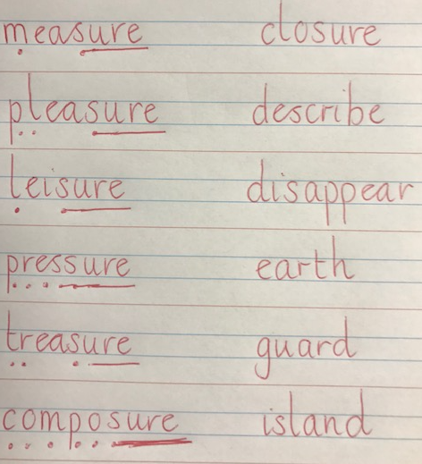
2 | pleasure
3 | leisure
4 | pressure
5 | treasure
6 | composure
7 | disclosure
8 | closure
 | Statutory Words
 | describe
 | disappear
 | earth
 | guard
 | island
Green: Just learn the green words and write them into 5 sentences.  Blue: Learn the green and blue words and write them into 5 sentences. |  | Both Green and Blue are to learn the 5 statutory words.  Use the sound buttons to help you.
Children will also be given two ‘unseen words’ during the test on Friday to assess their understanding of the week’s spelling rule.
Green: Tested on 12 words in total.
Blue: Tested on 15 words in total.

Spellings: Write each of your words 3 times in your homework book to help you remember how to spell them.
Sentence grammar focus: For five chosen rule words (not statutory), write five sentences that include paired adjectives. e.g The enormous, hairy minotaur had great pleasure fighting his enemy.
Remember to make sure you are writing neatly and using all appropriate punctuation.

Arithmetic
- Log in to Mathletics.com (direct link: https://community.mathletics.com/signin/#/student) and complete the assigned activities which we have set for you.  Learn your 3 times tables. |  |  | 3 times tables  1 x 3 = 3  2 x 3 = 6  3 x 3 = 9  4 x 3 = 12  5 x 3 = 15  6 x 3 = 18  7 x 3 = 21  8 x 3 = 24  9 x 3 = 27  10 x 3 = 30  11 x 3 = 33  12 x 3 = 36

