Year 3 Spellings Autumn 1: Week 5 10/10/24
Rule: words ending with ture – quite tricky this week |  | Handwriting Guide:
1 | mixture | 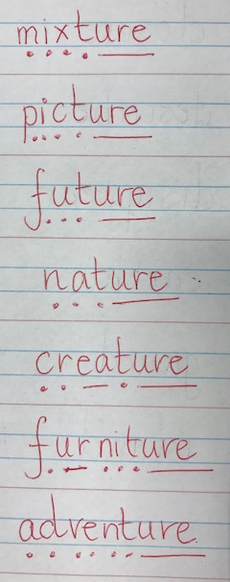
2 | picture
3 | future
4 | nature
5 | creature
6 | furniture
7 | adventure
8 | sculpture
 | Statutory Words!
 | natural
 | possible
 | possession
 | heard
 | occasion
Green: Just learn the green words and write them into 5 sentences.  Blue: Learn the green and blue words and write them into 5 sentences. |  | Both Green and Blue are to learn the 5 statutory words.  Use the sound buttons to help you.
Children will also be given two ‘unseen words’ during the test on Friday to assess their understanding of the week’s spelling rule.
Green: Tested on 12 words in total.
Blue: Tested on 15 words in total.

Spellings: Write each of your words 3 times onto the handwriting sheet to help you remember how to spell them.
Writing focus: A tricky but fun challenge this week! Use three of the chosen rule words (not statutory), to write a nonsense limerick – following the rhyming pattern (lines 1,2 and 5 and also lines 3 and 4) and the syllable count of 8,8,5,5,8. Don’t worry if it’s not a perfect match – have fun and play around with words! Still too tricky? Use your spelling words in a sentence with paired adjectives.

There once was a strange old creature (8)
Who had a brilliant future (8)
But she was not good (5)
Got stuck in the mud (5)
But what a super adventure! (8)

Arithmetic
- Log in to Mathletics.com (direct link: https://community.mathletics.com/signin/#/student) and complete the assigned activities which we have set for you.  Learn the 4 times tables. |  |  | 4 times tables  1 x 4 = 4 8 x 4 = 32  2 x 4 = 8 9 x 4 = 36  3 x 4 = 12 10 x 4 = 40  4 x 4 = 16 11 x 4 = 44  5 x 4 = 20 12 x 4 = 48  6 x 4 = 24  7 x 4 = 28

