Year 3 Spellings Autumn 1: Week 6 17/10/24
All words this week are statutory words, which follow no set rule, making them harder to learn. |  | Handwriting Guide:
1 | actual | 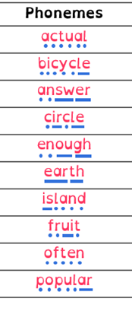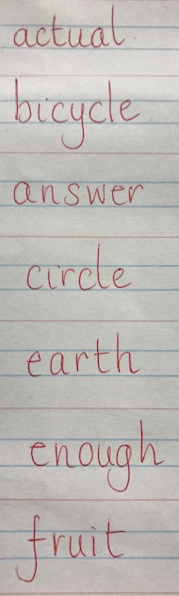
2 | bicycle
3 | answer
4 | circle
5 | earth
6 | enough
7 | fruit
8 | popular
9 | often
10 | island
Green: Just learn the green words and write them into 6 sentences.  Blue: Learn the green and blue words and write them into 6 sentences. |  | Use syllables and the sound buttons to help you.
As there is no spelling rule this week children will be tested on either:-
Green: Tested on 6 words in total.
Blue: Tested on 10 words in total.

Spellings: Write each of your words 3 times in your homework book to help you remember how to spell them.

Sentence grammar focus: Use time connectives and a country name for your homework this week.
e.g. Last year, I rode a bicycle through Spain.

Remember to make sure you are writing neatly and using all appropriate punctuation (remember capital letters for countries).
Arithmetic
- Log in to Mathletics.com (direct link: https://community.mathletics.com/signin/#/student) and complete the assigned activities which we have set for you.  Learn your 6 times tables.  Top tip – use your 3 times tables to help you with the 6 x tables because 6 is double 3! |  |  | 6 times tables  1 x 6 = 6  2 x 6 = 12  3 x 6 = 18  4 x 6 = 24  5 x 6 = 30  6 x 6 = 36  7 x 6 = 42  8 x 6 = 48  9 x 6 = 54  10 x 6 = 60  11 x 6 = 66  12 x 6 = 72

