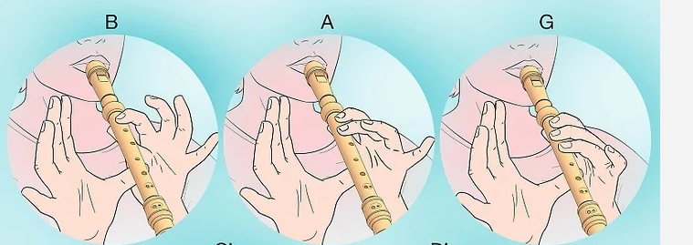

“BB Blues” uses the note “B”

“Thinking” uses the note A

Make sure you have covered the holes carefully otherwise it will squeak!! Blow gently into the mouthpiece.