Year 3 Spellings Autumn 2 : Week 1 7.11.24
All words this week all use the re- prefix
1 | redo | 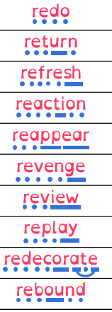  Use syllables and the sound buttons to help you.
2 | return
3 | refresh
4 | reaction
5 | reappear
6 | revenge
7 | review
8 | replay
9 | redecorate
10 | rebound
Statutory words
 | consider
 | continue
 | describe
 | different
 | difficult
Green: Just learn the green words and statutory words write them into 6 sentences.
Blue: Learn all the words and write them into 6 sentences.
This week children will be tested on either:-
Green: Tested on 11 words in total.
Blue: Tested on 15 words in total.
and two mystery words based on the rule.
Spellings: Write each of your words 3 times in your homework book to help you remember how to spell them.
This week, put the spelling words in alphabetical order and underline the base (root) word.

Sentence grammar focus: Use adverbs in your spelling homework this week.
e.g. I had to return quickly to fetch my coat because it was raining.

Remember to make sure you are writing neatly and using all appropriate punctuation.
Arithmetic
- Log in to Mathletics.com (direct link: https://community.mathletics.com/signin/#/student) and complete the assigned activities which we have set for you.  Another practise of your 6 times tables. Remember that your three times tables will help you! |  |  | 6 times tables  1 x 6 = 6  2 x 6 = 12  3 x 6 = 18  4 x 6 = 24  5 x 6 = 30  6 x 6 = 36  7 x 6 = 42  8 x 6 = 48  9 x 6 = 54  10 x 6 = 60  11 x 6 = 66  12 x 6 = 72

