Year 3 Spellings Spring : Week 4 28.11.24
All words this week using the suffixes ‘ing’, ‘er’ and ‘ed’
1 | gardening | Handwriting guide  Use syllables and the sound buttons to help you.  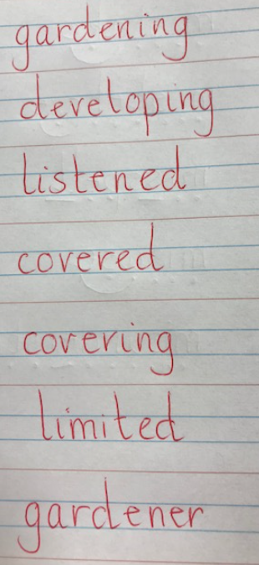
2 | gardener
3 | listening
4 | listened
5 | developed
6 | developing
7 | limiting
8 | limited
Statutory words!
1 | separate
2 | special
3 | straight
4 | strange
5 | strength
Green: Just learn the green words and statutory words write them into 5 sentences.
Blue: Learn all the words and write them into 6 sentences.
This week children will be tested on either:-
Green: Tested on 12 words in total.
Blue: Tested on 15 words in total.
AND two mystery words based on the rule.
Spellings: Write each of your words 3 times in your homework book to help you remember how to spell them.

Sentence grammar focus: Use adverbs and adjectives in in your spelling homework this week.
e.g. The gardener carefully planted the young seedlings.

Remember to make sure you are writing neatly and using all appropriate punctuation.
Arithmetic
- Log in to Mathletics.com (direct link: https://community.mathletics.com/signin/#/student) and complete the assigned activities which we have set for you.  If you would like a challenge, try these:-  For example, we know 4 x 9 = 36 so 40 x 9 = 360  10 x 9 =  20 x 9 =  30 x 9 =  40 x 9 =  50 x 9 =  60 x 9 =  70 x 9 =  80 x 9 =  90 x 9 =  100 x 9 =  110 x 9 =  120 x 9 = |  |  | 9 times tables!  1 x 9 = 9  2 x 9 = 18  3 x 9 = 27  4 x 9 = 36  5 x 9 = 45  6 x 9 = 54  7 x 9 = 63  8 x 9 = 72  9 x 9 = 81  10 x 9 = 90  11 x 9 = 99  12 x 9 = 108

