Year 3 Spellings Autumn : Week 6 5.12.24
All words this week are challenge words
1 | centre | Handwriting guide  Use syllables and the sound buttons to help you.  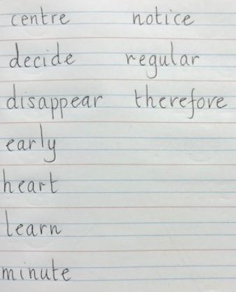
2 | decide
3 | early
4 | heart
5 | minute
6 | disappear
7 | notice
8 | regular
Statutory words!
1 | therefore
2 | imagine
3 | height
4 | increase
5 | library
Green: Just learn the green words and statutory words write them into 5 sentences.

Blue: Learn all the words and write them into 6 sentences.
This week children will be tested on either:-
Green: Tested on 10 words in total.
Blue: Tested on 13 words in total.

Spellings: Write each of your words 3 times in your homework book to help you remember how to spell them.

Sentence grammar focus: Use prepositions in in your spelling homework this week.
e.g. They had to decide if they wanted to place the ball in the middle of the field.

Remember to make sure you are writing neatly and using all appropriate punctuation.
Arithmetic
- Log in to Mathletics.com (direct link: https://community.mathletics.com/signin/#/student) and complete the assigned activities which we have set for you. |  |  | 11 times tables!  1 x 11 = 11  2 x 11 = 22  3 x 11 = 33  4 x 11 = 44  5 x 11 = 55  6 x 11 = 66  7 x 11 = 77  8 x 11 = 88  9 x 11 = 99  10 x 11 = 110  11 x 11 = 121  12 x 12 = 132

