Year 3 Spellings Spring : Week 1 9.1.25 – Happy New Year!
All words this week using ‘ai’
Rhyme: snail in the rain
1 | waist | Handwriting guide  Use syllables and the sound buttons to help you.  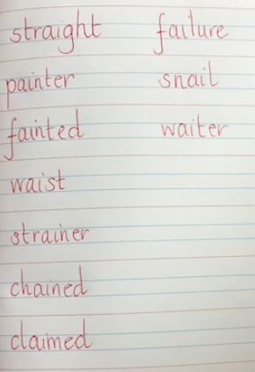
2 | snail
3 | waiter
4 | chained
5 | painter
6 | straight
7 | strainer
8 | failure
Statutory words!
1 | extreme
2 | famous
3 | February
4 | forward
5 | fruit
Green: Just learn the green words and statutory words write them into 5 sentences.
Blue: Learn all the words and write them into 6 sentences.
This week children will be tested on either:-
Green: Tested on 12 words in total.
Blue: Tested on 15 words in total.
AND two unlisted words based on the rule.
Spellings: Write each of your words 3 times in your homework book to help you remember how to spell them. Order them alphabetically in a list.

Sentence grammar focus: Use the spelling word in a factual sentence as if it is in a non-fiction text. It is challenge but try your best.
e.g. Snails hibernate in the winter.

Remember to make sure you are writing neatly and using all appropriate punctuation.
Arithmetic
- Log in to Mathletics.com (direct link: https://community.mathletics.com/signin/#/student) and complete the assigned activities which we have set for you.  - Make sure you learn the 12 times table. Knowing your 3 and 4 times tables make this easier! |  |  | 12 Times Table  1 x 12 = 12  2 x 12 = 24  3 x 12 = 36  4 x 12 = 48  5 x 12 = 60  6 x 12 = 72  7 x 12 = 84  8 x 12 = 96  9 x 12 = 108  10 x 12 = 120  11 x 12 = 132  12 x 12 = 144

