Year 3 Spellings Spring 1: Week 2 16.01.25
All words this week using ‘ei’
1 | vein | Handwriting guide  Use syllables and the sound buttons to help you.  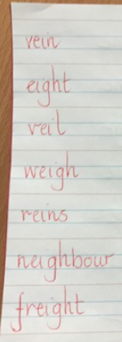
2 | eight
3 | veil
4 | weigh
5 | reins
6 | reign
7 | neighbour
8 | freight
Statutory words!
1 | grammar
2 | group
3 | guard
4 | guide
5 | heard
Green: Just learn the green words and statutory words write them into 5 sentences.
Blue: Learn all the words and write them into 6 sentences.
This week children will be tested on either:-
Green: Tested on 12 words in total.
Blue: Tested on 15 words in total.
AND two unlisted words based on the rule.
Spellings: Write each of your words 3 times in your homework book to help you remember how to spell them. Order them alphabetically in a list.

Sentence grammar focus: Use either a question mark or an exclamation mark in each sentence.
“Eight jam donuts!” squealed Ella excitedly.
Did you know that freight trains are really important?

Remember to make sure you are writing neatly and using all appropriate punctuation.
Arithmetic  - Log in to Mathletics.com (direct link: https://community.mathletics.com/signin/#/student) and complete the assigned activities which we have set for you.  - Make sure you learn the times table. Know them already? Then practice writing down the inverse.  e.g.  1 x 2 = 2  2 ÷ 1 = 2  2 x 2 = 4  4 ÷ 2 = 2 |  |  | 2 Times Table  1 x 2 = 2  2 x 2 = 4  3 x 2 = 6  4 x 2 = 8  5 x 2 = 10  6 x 2 = 12  7 x 2 = 14  8 x 2 = 16  9 x 2 = 18  10 x 2 = 20  11 x 2 = 22  12 x 2 = 24

